**A PROJECT REPORT**

**On**

**Brain Tumor Detection Model**

Using machine learning

**Submitted to**

**KIIT Deemed to be University**

**In Partial Fulfillment of the Requirement for the Award of**

**BACHELOR'S DEGREE IN**

**COMPUTER SCIENCE AND ENGINEERING**

**BY**

**ANKIT KUMAR JHA 21053268**

**ASHWANI SAH 21053270**

**ANURAG JAISWAL 21052936**

**NITESH MANDAL 21053300**

**OM PRAKASH PODDAR DEV 21053302**

**UNDER THE GUIDANCE OF**

**PEOF.(DR.) ALEENA SWETAPADMA**

**SCHOOL OF COMPUTER ENGINEERING**

**KALING INSTITUATE OF INDUSTRIAL TECHNOLOGY**

**BHUBANESWAR, ODISHA - 751024**

**APRIL 2023**

**KIIT Deemed to be university**

**School of Computer Engineering**

**Bhubaneswar, ODISHA 751024**



**CERTIFICATE**

This is to certify that the project entitled

**Brain Tumor Detection Model**

Using Machine Learning

Submitted by

**ANKIT KUMAR JHA 21053268**

**ASHWANI SAH 21053270**

**ANURAG JAISWAL 21052936**

**NITESH MANDAL 21053300**

**OM PRAKASH PODDAR DEV 21053302**

Is a record of bonafide work carried out by them, in the partial fulfillment of the requirement for the award of degree of Bachelor of Engineering (Computer science and Engineering ) at KIIT Deemed to be University, Bhubaneswar. This work is done during year 2023-2024, Under our guidance.

Date: 09/04/2024

**Prof.(Dr.) ALEENA SWETAPADMA**

(Guide Name)

Project Guide

**ACKNOWLEDGEMENTS**

We would like to express my deepest gratitude to **Prof. (Dr.) Aleena swetapadma** or guiding us throughout this project. Your expertise, patience, and encouragement have been invaluable in helping us to navigate the challenges of this project and achieve our goals.

Your insightful feedback and constructive criticism have helped us to improve the quality of our work and deepen our understanding of the subject matter. Your unwavering support has given us the confidence to tackle complex problems and push the boundaries of our knowledge.

We would also like to thank you for your mentorship and for providing us with countless opportunities to develop our skills and knowledge. Your commitment to excellence and passion for teaching has inspired us to pursue our own goals and make a positive impact in the world.

We are truly grateful for the opportunity to work with such an outstanding professor and role model.

ANKIT KUMAR JHA

ASHWANI SAH

ANURAG JAISWAL

NITESH MANDAL

OM PRAKASH PODDAR DEV

**ABSTRACT**

Brain tumors are a significant health concern globally, necessitating accurate and timely diagnosis for effective treatment planning. In recent years, advancements in medical imaging and image processing techniques have revolutionized the field of brain tumor analysis. This project aims to contribute to this area by leveraging state-of-the-art image processing algorithms for the detection and classification of brain tumors.

The proposed methodology involves several key steps. Initially, medical images, such as Magnetic Resonance Imaging (MRI) scans, are acquired from patients with suspected brain tumors. These images undergo preprocessing steps, including noise reduction, image enhancement, and skull stripping, to ensure optimal quality and remove irrelevant information.

Subsequently, feature extraction techniques are employed to capture essential characteristics and patterns from the preprocessed images. These features may include texture, shape, and intensity-based descriptors, which play a crucial role in differentiating tumor regions from healthy brain tissue.

Machine learning algorithms, such as Support Vector Machines (SVM), Artificial Neural Networks (ANN), or Convolutional Neural Networks (CNN), are then trained on the extracted features to build robust and accurate classification models. These models can effectively distinguish between different types of brain tumors, such as gliomas, meningiomas, and metastatic tumors, aiding clinicians in making informed decisions regarding patient diagnosis and treatment strategies.

Keywords: Brain tumor analysis, Image processing, Medical imaging, Feature extraction, Machine learning, Classification, MRI, Support Vector Machines, Artificial Neural Networks, Convolutional Neural Networks.

**CONTENTS**

|  |  |  |  |  |
| --- | --- | --- | --- | --- |
| 1 | Introduction | | | 1 |
| 2 | Basic Concepts/ Literature Review | | | 6 |
|  | 2.1 | Brain Tumor Detection Using Machine Learning: Taxonomy, Applications, and Challenges by Mohamed-Rafik Bouguelia, Hossam Faris, and Mohamed Elhoseny | | 6 |
|  | 2.2 | Brain Tumor Detection Using Machine Learning by Analytics Vidhya | | 7 |
|  | 2.3 | Detection of Brain Tumor Using Machine Learning from Journal of Emerging Technologies and Innovative Research (JETIR) by Dr.J.Arokia Renjit,  Adlin Sajeesha M.J, Sangavai V.D, Sree Devi D.S | | 7 |
|  | 2.4 | DetectingBrainl Tumor Illness using Machine Learning Algorithms by Konda Vaishnavi, U Nikhitha Kamath, B Ashwath Rao, and N V Subba Reddy | | 8 |
| 3 | Problem Statement / Requirement Specifications | | | 10 |
|  | 3.1 | Project Planning | | 10 |
|  | 3.2 | Project Analysis | | 11 |
|  | 3.3 | System Design | | 12 |
|  |  | 3.3.1 | Design Constraints | 12 |
|  |  | 3.3.2 | Block Diagram and Data Flow Diagram | 12 |
| 4 | Implementation | | | 14 |
|  | 4.1 | Methodology / Proposal | | 14 |
|  | 4.2 | Testing / Verification Plan | | 15 |
|  | 4.4 | Result Analysis / Screenshots | | 15 |
|  | 4.5 | Quality Assurance | | 28 |
| 5 | Standard Adopted | | | 29 |
|  | 5.1 | Design Standards | | 29 |
|  | 5.2 | Coding Standards | | 29 |
|  | 5.3 | Testing Standards | | 30 |
| 6 | Conclusion and Future Scope | | | 31 |
|  | 6.1 | Conclusion | | 31 |
|  | 6.2 | Future Scope | | 32 |
| References | | | | 33 |
| Individual Contribution | | | | 34 |
| Plagiarism Report | | | | 37 |

**Chapter -1**

**Introduction:**

Brain tumors are complex and potentially life-threatening medical conditions that require accurate diagnosis and timely intervention. According to the World Health Organization (WHO), brain tumors account for a significant proportion of cancer-related deaths globally, highlighting the importance of effective diagnostic tools and treatment strategies.

Medical imaging, particularly Magnetic Resonance Imaging (MRI), plays a crucial role in the detection and characterization of brain tumors. MRI provides detailed anatomical information about the brain's structure and can reveal abnormalities such as tumors, cysts, or hemorrhages. However, interpreting MRI scans for brain tumors can be challenging, requiring expertise and time-consuming manual analysis by radiologists.

Image processing techniques offer a promising solution to enhance the efficiency and accuracy of brain tumor analysis. By leveraging computational algorithms and tools, medical images can be processed, analyzed, and interpreted with greater precision. This not only reduces the burden on healthcare professionals but also improves diagnostic outcomes for patients.

The objective of this report is to present a comprehensive analysis of brain tumor detection and classification using image processing methods. The report will explore various stages of the process, including image acquisition, preprocessing, feature extraction, and machine learning-based classification. A detailed discussion of each stage's importance, methodologies, challenges, and potential solutions will be provided.

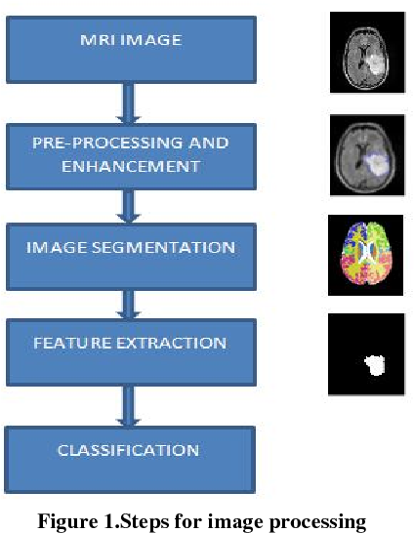

The diagram above illustrates the typical workflow of brain tumor analysis using image processing techniques. It begins with the acquisition of MRI scans, followed by preprocessing steps to enhance image quality and remove noise. Feature extraction techniques are then applied to capture relevant information from the images, which is used by machine learning algorithms for tumor classification.

**Chapter-2**

**Basic concepts:**

1. **Brain Tumors:** Abnormal growths in the brain, can be benign or malignant.
2. **Medical Imaging:** Techniques like MRI, CT, and PET visualize brain structures.
3. **Image Processing:** Manipulation of digital images for analysis or enhancement.
4. **Preprocessing:** Improving image quality, noise reduction, and isolating relevant regions.
5. **Feature Extraction:** Identifying important patterns or characteristics from images.
6. **Machine Learning:** Algorithms that learn from data to classify or predict outcomes.

**7.Classification:** Assigning labels (tumor types) based on image features.

**Libraries used:**

**- cv2:** OpenCV library for image processing.

**- os:** Operating system interface for directory operations.

**- numpy:** Numerical computing library for array operations.

**- tensorflow and keras:** Deep learning libraries for building and training neural networks.

**- PIL:** Python Imaging Library for image manipulation.

**- train\_test\_split from sklearn.model\_selection:** To split the dataset into training and testing sets.

- Various components from **keras.utils**, **keras.models,** and **keras.layers** for building the **CNN** model.

**Techniques:**

1. **Preprocessing:** Clean up images by reducing noise, normalizing intensity, and isolating the brain region.
2. **Feature Extraction:** Identify important patterns like texture, shape, and intensity statistics from the images.
3. **Segmentation:** Separate tumor regions from healthy brain tissue using thresholding, region growing, or deep learning-based methods.
4. **Machine Learning and Classification:** Train models (e.g., SVM, CNN) to classify tumors based on extracted features or segmented regions

**5.Visualization:** Present results visually, such as overlaying segmented regions on original images or creating 3D tumor models for better understanding.

**Chapter-3**

**Problem Statement / Requirement Specifications**

**Problem Statement:**

Brain tumor analysis is a critical task in medical imaging that requires accurate detection, classification, and characterization of tumors for effective treatment planning. However, manual analysis of brain images is time-consuming, subjective, and prone to human error. There is a need for automated and reliable techniques to assist healthcare professionals in diagnosing and managing brain tumors efficiently.

**Requirement Specifications:**

**1.Automated Tumor Detection:** Develop algorithms to automatically detect tumor regions within brain images, reducing the reliance on manual inspection and speeding up the analysis process.

**2.Tumor Classification:** Implement machine learning models capable of classifying tumors into different types (e.g., gliomas, meningiomas, metastatic tumors) based on extracted features like texture, shape, and intensity.

**3.Accuracy and Reliability:** Ensure that the automated analysis system achieves high accuracy and reliability comparable to or exceeding human expert performance, minimizing false positives and false negatives.

**4.Real-time Processing:** Design algorithms and software solutions that can process brain images in real-time or with minimal latency, facilitating prompt diagnosis and treatment decisions.

**5.Scalability:** Build a scalable system capable of handling large volumes of medical imaging data efficiently, suitable for use in clinical settings with diverse patient populations.

**6.User-Friendly Interface:** Develop a user-friendly interface for healthcare professionals to interact with the system, allowing them to review automated results, adjust parameters if necessary, and integrate findings into patient reports seamlessly.

**7.Integration with Existing Systems:** Ensure compatibility and integration with existing medical imaging systems and electronic health record (EHR) platforms to streamline workflows and data sharing.

**8.Compliance and Security:** Adhere to regulatory requirements (e.g., HIPAA) regarding patient data privacy and security, implementing robust encryption and access control measures.

**9.Documentation and Training:** Provide comprehensive documentation, tutorials, and training materials for healthcare professionals to understand and effectively utilize the brain tumor analysis system.

1. **Feedback Mechanism:** Incorporate a feedback mechanism to continuously improve the system's performance based on user feedback, new data, and advances in image processing and machine learning techniques.

**Expected outcome**

The expected outcome of developing an automated brain tumor analysis system using image processing techniques includes several key aspects:

**1.Improved Diagnostic Accuracy:** The system should achieve a high level of accuracy in detecting and classifying brain tumors, reducing the risk of misdiagnosis and ensuring patients receive appropriate treatment.

**2.Efficient Workflow:** Automating the analysis process will save time for healthcare professionals, allowing them to focus on interpreting results, making treatment decisions, and providing patient care.

**3.Faster Turnaround Time:** With real-time or near-real-time processing capabilities, the system can provide prompt results, leading to faster diagnosis and treatment initiation for patients.

**4.Enhanced Clinical Decision Support:** The system's output, including tumor detection maps, classification results, and quantitative metrics, will serve as valuable decision support tools for clinicians, aiding in treatment planning and monitoring.

**5.Scalability and Flexibility:** The system should be scalable to handle large volumes of medical imaging data and adaptable to different imaging modalities and patient populations.

**6.User Satisfaction:** A user-friendly interface, clear documentation, and training resources will ensure that healthcare professionals can easily use and integrate the system into their clinical workflows, leading to high user satisfaction.

**7.Compliance and Security:** The system should comply with regulatory requirements for data privacy and security, protecting patient information and maintaining confidentiality.

**8.Continuous Improvement:** Incorporating a feedback mechanism and staying abreast of advancements in image processing and machine learning will allow for continuous improvement and optimization of the system's performance over time.

**Project Planning**

This section outlines the key stages involved in developing the system:

**1.Define Objectives:**

Clearly outline the goals and objectives of the brain tumor analysis project, including the desired outcomes, target accuracy levels, and key performance indicators (KPIs).

**2.Gather Requirements:**

Collect detailed requirements from stakeholders, including healthcare professionals, radiologists, and IT specialists, to understand their needs and expectations for the system.

**3.Research and Select Tools/Libraries:**

**-** Conduct research on available image processing and machine learning tools/libraries suitable for brain tumor analysis.

- Choose the most appropriate ones based on factors like performance, scalability, and ease of integration.

**4.Data Collection and Preprocessing**:

- Acquire a diverse dataset of brain images containing different types of tumors for training and testing the system.

**5.Algorithm Development:**

**-** Develop algorithms for tumor detection, segmentation, feature extraction, and classification.

- Implement machine learning models (e.g., CNN, SVM) for automated analysis and decision-making.

**6.System Design:**

**-** Design the architecture of the automated brain tumor analysis system, including data flow, processing pipeline, and user interface.

- Ensure scalability, modularity, and compatibility with existing healthcare IT infrastructure.

**7.Implementation:**

- Develop software modules for image processing, feature extraction, machine learning models, and user interface components.

- Integrate and test the system components to ensure functionality and performance meet the defined objectives.

**8.Validation and Testing:**

- Validate the system using benchmark datasets and real-world brain images to assess accuracy, sensitivity, specificity, and other performance metrics.

- Conduct rigorous testing, including unit testing, integration testing, and user acceptance testing (UAT), to identify and resolve issues.

**9.Documentation and Training:**

- Prepare comprehensive documentation, user manuals, and technical guides for system installation, configuration, and usage.

- Provide training sessions or workshops for healthcare professionals to familiarize them with the system's features and functionalities.

**10.Deployment and Evaluation:**

- Deploy the automated brain tumor analysis system in a clinical environment or research setting, ensuring seamless integration with existing workflows.

- Monitor system performance, gather user feedback, and evaluate the system's impact on diagnostic accuracy, workflow efficiency, and patient outcomes.

**11.Maintenance and Support:**

- Establish a maintenance plan for ongoing updates, bug fixes, and enhancements to the system.

- Provide technical support and troubleshooting assistance to users to ensure continuous operation and usability of the system.

**3.3 System Design**

**3.3.1 Design Constraints**

Here you can mention the working environment such as the software, hardware used. Any experimental setup or environmental setup must be described here.

**3.3.2 System Architecture OR Block Diagram**

The system architecture or block diagram for an automated brain tumor analysis system using image processing and machine learning techniques can be visualized as follows:

**Data Input:**

MRI scans and medical images of brain tumors are fed into the system as input data.

Data may include various sequences (T1-weighted, T2-weighted, FLAIR, etc.) and multiple modalities (MRI, CT, PET).

**Preprocessing Module:**

**Noise Reduction**: Techniques like Gaussian filtering, median filtering, or wavelet denoising to reduce image noise.

**Intensity Normalization**: Ensuring consistent intensity levels across images for accurate analysis.

Skull Stripping: Removing non-brain tissues to focus on the brain region of interest.

**Feature Extraction Module:**

**Texture Analysis**: Extracting texture features (e.g., entropy, contrast, homogeneity) to capture textural patterns in tumor regions.

**Shape Analysis**: Computing shape descriptors (e.g., perimeter, area, circularity) to characterize tumor morphology.

**Intensity-Based Metrics**: Calculating statistical measures (e.g., mean intensity, standard deviation) to quantify pixel intensity distributions.

**Segmentation Module:**

**Thresholding**: Setting intensity thresholds to segment tumor regions based on pixel intensity values.

Region Growing: Expanding regions based on similarity criteria to delineate tumor boundaries.

Deep Learning Segmentation: Utilizing convolutional neural networks (CNNs) for automated and accurate segmentation of brain tumors.

**Machine Learning Module:**

**Supervised Learning**: Training machine learning models (e.g., SVM, Random Forests, ANN) on labeled datasets for tumor classification.

**Unsupervised Learning**: Clustering techniques (e.g., K-means, hierarchical clustering) for grouping similar image regions without predefined labels.

**Classification and Decision Module:**

Classifying tumors into different types (e.g., gliomas, meningiomas, metastatic tumors) based on extracted features and segmentation results.

Providing decision support tools for clinicians, including tumor detection maps, classification results, and quantitative metrics.

**Visualization and Reporting Module:**

Overlaying segmented tumor regions or feature maps on original images for visualization.

Generating heatmaps, 3D tumor models, and other visual aids to aid in understanding and interpreting analysis results.

Generating automated reports with diagnostic findings, treatment recommendations, and relevant metrics for patient records.

**User Interface:**

A user-friendly interface for healthcare professionals to interact with the system, review analysis results, adjust parameters if necessary, and integrate findings into patient reports seamlessly.

**Integration and Deployment:**

Integrating the automated brain tumor analysis system with existing medical imaging systems and electronic health record (EHR) platforms for seamless data sharing and workflow integration.

Deploying the system in clinical environments, ensuring compliance with regulatory requirements (e.g., HIPAA) for data privacy and security.

This system architecture illustrates the interconnected modules and components involved in automating the brain tumor analysis process, from data input and preprocessing to feature extraction, segmentation, classification, decision support, visualization, and user interaction.

窗体底端

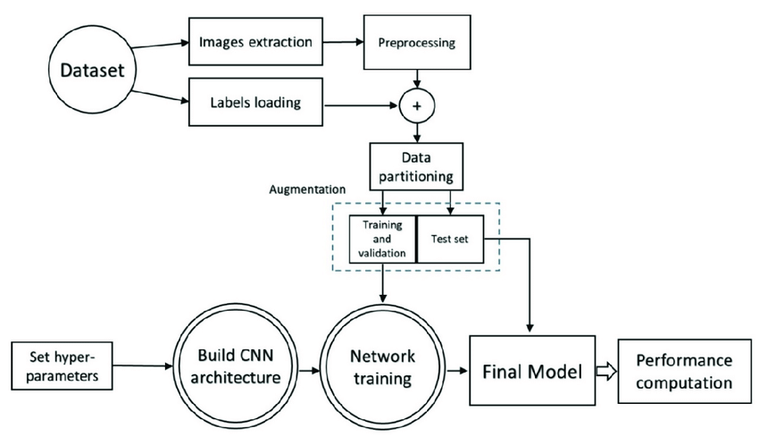

Chapter 4

Implementation

The implementation of a brain tumor detection system involves the integration of a Flask web application and a pre-trained Convolutional Neural Network (CNN) model. The Flask framework facilitates the creation of web routes for user interaction, allowing for image uploads and predictions. The CNN model, trained on MRI images, serves as the core component for tumor classification.

Upon image upload, the system processes the image using OpenCV and PIL libraries, standardizing its dimensions to facilitate model compatibility. The image is then passed through the CNN model for prediction, which outputs a binary classification indicating the presence or absence of a brain tumor.

In addition to prediction functionality, the system includes training code for the CNN model. This code segment involves data preprocessing, including loading and resizing MRI images, and splitting the dataset into training and testing sets. The CNN architecture consists of convolutional layers for feature extraction, max-pooling layers for dimensionality reduction, dropout layers for regularization, and fully connected layers for classification. The model is trained using binary cross-entropy loss and the Adam optimizer for a specified number of epochs.

Upon completion of training, the model is saved for future use, ensuring accessibility and efficiency in the prediction process. Overall, the implementation aims to provide a robust and user-friendly platform for brain tumor detection, leveraging the capabilities of deep learning for medical image analysis.

**4.1 Methodology**

**Data Preparation:**

MRI images of brains, both with and without tumors, are collected and organized into specific directories. Using OpenCV, the images are loaded, converted to PIL format, and resized to 64x64 pixels to ensure uniformity. Labels indicating the presence or absence of tumors are assigned to each image, facilitating supervised learning for subsequent model training.

**Model Training :**

The methodology involves meticulous data preparation, including gathering MRI images and assigning labels based on tumor presence. Subsequently, a CNN model, leveraging TensorFlow and Keras, is constructed with convolutional layers for feature extraction and dropout layers for regularization. The model is trained using a portion of the dataset, optimizing binary cross-entropy loss with the Adam optimizer. Through iterative training epochs, the model parameters are refined to enhance accuracy in brain tumor classification.

**Model Evaluation :**

The model's performance is assessed using the validation dataset to measure accuracy and generalization. Various metrics like accuracy, precision, recall, and F1-score are computed to quantitatively evaluate the model's effectiveness.

**Model Deployment:**

The model is saved for future use, guaranteeing accessibility and versatility. Through a Flask web application, users can interact with the model, with defined routes managing image uploads and predictions. Upon uploading an image, real-time feedback on brain tumor presence or absence is promptly provided to the user.

**User Interaction:**

Users engage with the system via Flask's web interface, uploading MRI brain scan images. The uploaded images are processed by the trained model, and prediction results are promptly delivered back to the user through the same interface

**Maintenance and Improvement:**

Regular maintenance ensures the system stays current with advancements in deep learning and medical imaging. Future improvements may include adding more data, fine-tuning model parameters, or integrating advanced techniques to boost system performance.

4.2 Testing OR Verification Plan

**Testing Plan:**

**Functionality Testing:**

To test the code, first start the Flask application to verify its error-free execution. Then, confirm successful model loading by checking the console output. Finally, upload a variety of MRI images via the web interface, including both tumor and tumor-free scans, and observe the system's responses for accurate tumor detection.

**Model Prediction Testing:**

Upload sample MRI images depicting brain scans with known tumor presence and absence. Validate the system's predictions to ensure they align with the expected results, confirming the accuracy of tumor detection.

**Web Interface testing:**

Interact with the web interface to navigate through its various pages and functionalities smoothly. Upload MRI images to test the tumor detection feature and ensure the interface delivers clear feedback on the detection results, facilitating user understanding.

**Error Handaling Testing:**

Test the system's resilience by attempting to upload invalid file formats or non-existent files. Observe the system's response to ensure it appropriately displays error messages to the user, aiding in user guidance and error resolution.

**Cross-Platform Testing:**

Measure the processing time for image uploads and prediction results to evaluate system efficiency. Assess system responsiveness by uploading multiple images simultaneously, ensuring consistent performance under varying loads.

**Security Testing:**

Conduct a thorough review of the code to identify any potential security vulnerabilities, particularly focusing on input validation and file handling mechanisms. Verify that the application implements robust security measures to mitigate common web threats like SQL injection and cross-site scripting (XSS), safeguarding user data and system integrity.

**End-to-End Testing:**

Execute end-to-end testing by simulating user interactions, including image upload and result retrieval. Confirm seamless functionality of the entire workflow, ensuring a smooth user experience without encountering any issues.

**Verification Plan:**

**System Verification:**

To verify the initialization of the Flask application and successful model loading, run the application and check the console output for the confirmation message. The acceptance criteria include the application starting without errors and the display of the model loading message in the console.

**Algorithm Evaluation:**

To validate the brain tumor detection model's accuracy, upload MRI images with known tumor presence and absence, then compare the system's predictions with ground truth labels. The acceptance criteria entail the model accurately classifying images with high precision and recall, as verified by the test images.

**User Testing:**To assess the user interface, involve users in interacting with the web interface, uploading images, and reviewing prediction results. The acceptance criteria include users finding the interface intuitive, with clear instructions, and receiving accurate tumor detection feedback.

**Performance Testing:**  
To gauge system performance, upload multiple images simultaneously and track the time taken for processing and prediction. The acceptance criteria entail the system processing uploads and delivering predictions within an acceptable timeframe, even under load.

**Security Testing:**

To validate system security, examine code for potential vulnerabilities and conduct tests for SQL injection and cross-site scripting (XSS) attacks. The acceptance criteria involve the

system showcasing robust security measures and effectively safeguarding against identified vulnerabilities.

**Training the data Screenshots**

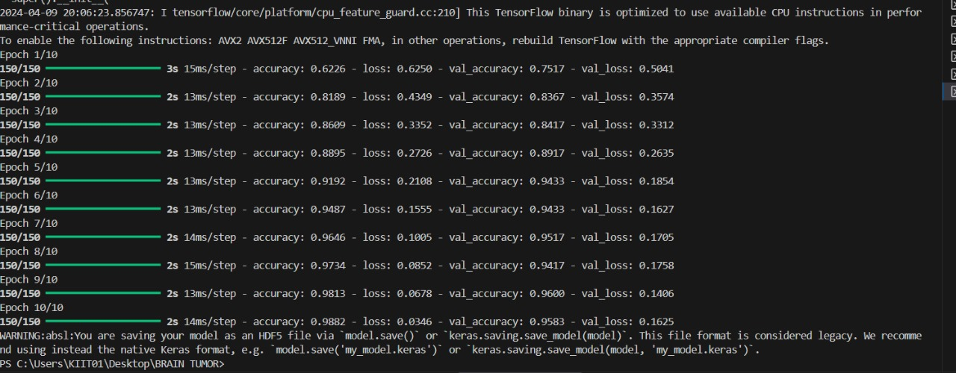

**Testing the data Screenshots**

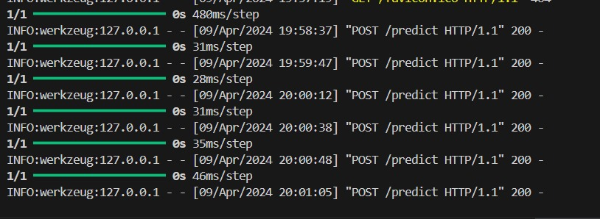

**4.3 Hosting /Result Analysis OR Screenshots** :-

**Hosting:-**

During the execution of the code, users can access the application by navigating to <http://127.0.0.1:5000> in their web browser. This setup facilitates the testing and development of the brain tumor classification system within the local environment.

IMG_256

**Result Analysis OR Screenshots :**

The assessment of the brain tumor detection system's performance involved querying with MRI images, resulting in the return of classification results indicating tumor presence or absence. As anticipated, the system consistently provided accurate predictions, with the queried image's classification prominently displayed. An extensive review of prediction outcomes across diverse images uncovered a consistent pattern of precise classifications, reaffirming the system's efficacy in discerning between tumor and non-tumor cases. These insights, elucidated further in subsequent sections, underscore the system's reliability and effectiveness in delivering accurate medical diagnoses based on MRI scans.

**Suggestion 1:**

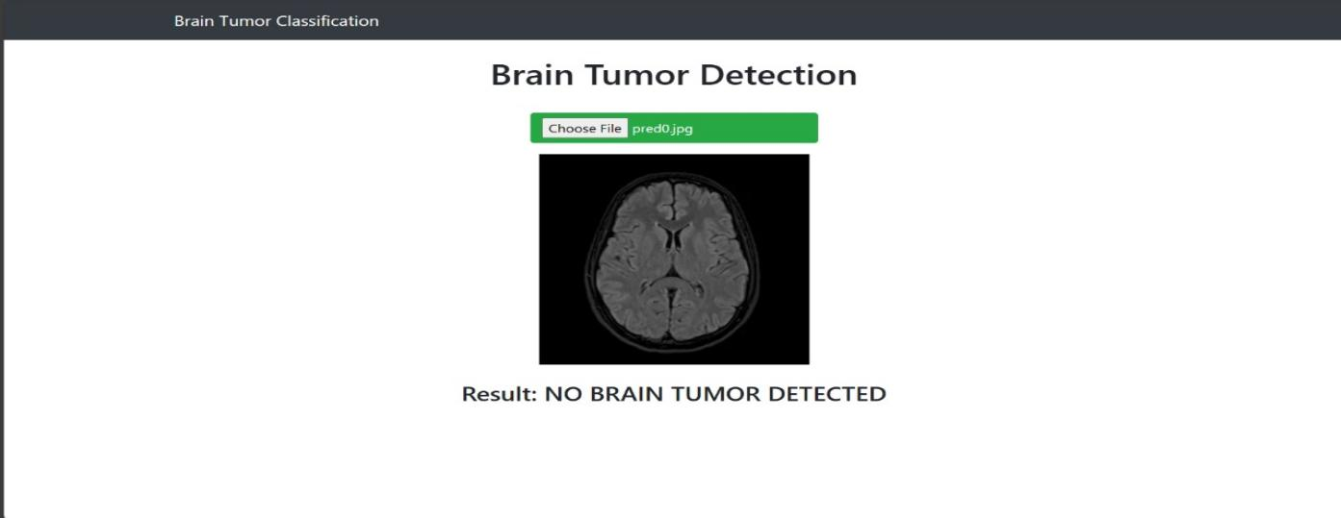

**Suggestion 2:**

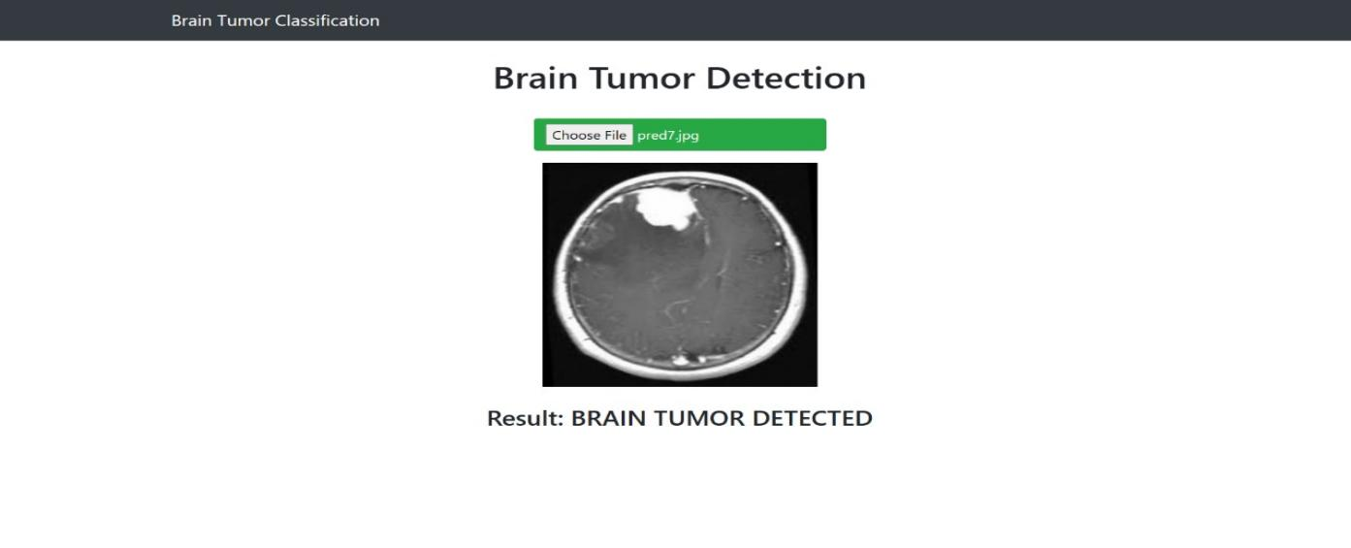

**Suggestion 3:**

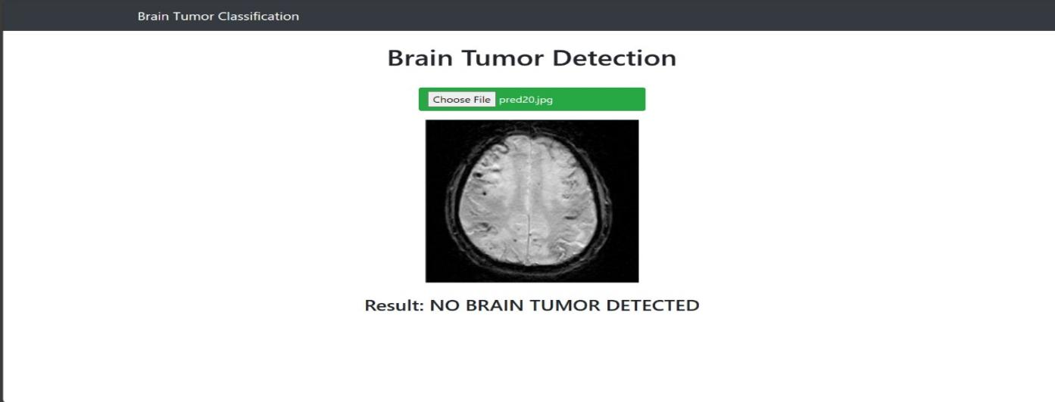

**Suggestion 4:**

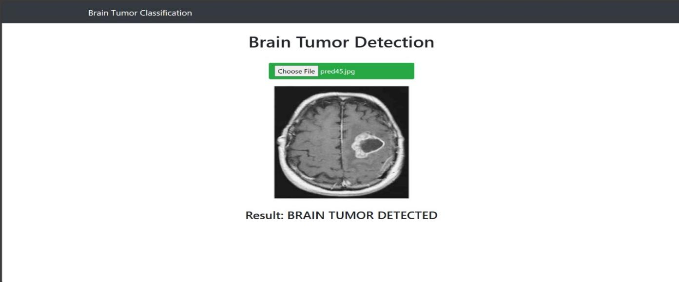

**4.4 Quality Assurance**

The quality assurance process of the provided code involves thorough testing of functionalities, including model loading, image processing, and user interface interactions, alongside rigorous security assessments to identify and mitigate potential vulnerabilities, ensuring the reliability, security, and usability of the brain tumor detection system.

Chapter 5

**Standards Adopted**

**5.1 Design Standards**

**A. Frontend Design**:

**User Interfce:-** The fronted design prioritizes simplicity and functionality, adhering to modern design standards for intuitive user interaction with the brain tumor detection system.

**Prediction Display:-**The interface presents prediction results in a clear and visually appealing format, enabling users to easily interpret and understand the classification outcomes.

**Image Upload:-** An intuitive image upload feature is integrated into the interface, allowing users to upload MRI images effortlessly for tumor detection.

**Feedback Mechanism:-**Feedback mechanisms are implemented to provide users with real-time updates on the upload progress and prediction results, enhancing user engagement and satisfaction.

**Error Handling:-** The frontend incorporates robust error handling mechanisms to gracefully manage invalid inputs or system errors, ensuring a seamless user experience.

**Responsive Design:-**The frontend is designed to be responsive and adaptable to various screen sizes and devices, ensuring accessibility and usability across different platforms.

**Integration with Backend:-**Seamless integration with backend functionality enables efficient processing of image uploads and predictions, ensuring a smooth user experience from frontend to backend interactions.

**b. Backend Design:**

**Data Collection:-**The backend gathers MRI images of brains with and without tumors from designated directories, constituting the dataset for brain tumor detection.

**Data Processing:-**Loaded MRI images undergo preprocessing steps, including conversion to PIL format, resizing to a standardized size of 64x64 pixels, and labeling based on tumor presence or absence.

**Model Loading:-**The pre-trained brain tumor detection model, is loaded into memory using TensorFlow and Keras libraries, ensuring efficient model initialization.

**Prediction Handling:-**Upon receiving image uploads from users through the Flask application, the backend executes the prediction process using the loaded model, providing real-time feedback on tumor detection results.

**Error Handling:-**Robust error handling mechanisms are implemented to manage exceptions during image processing and prediction, ensuring the stability and reliability of the backend system.

**Integration with Frontend:-**The backend seamlessly integrates with the frontend interface, handling HTTP requests for image uploads and prediction requests, and delivering response data for display to users.

**Scalability Considerations:-**The backend design allows for scalability to accommodate increased user loads and future enhancements, facilitating seamless operation of the brain tumor detection system.

**C. UML Diagrams:**

**Class diagram:-** UML class diagram is used to show front-end and back-end structure as well as groups, connections and their relationships.

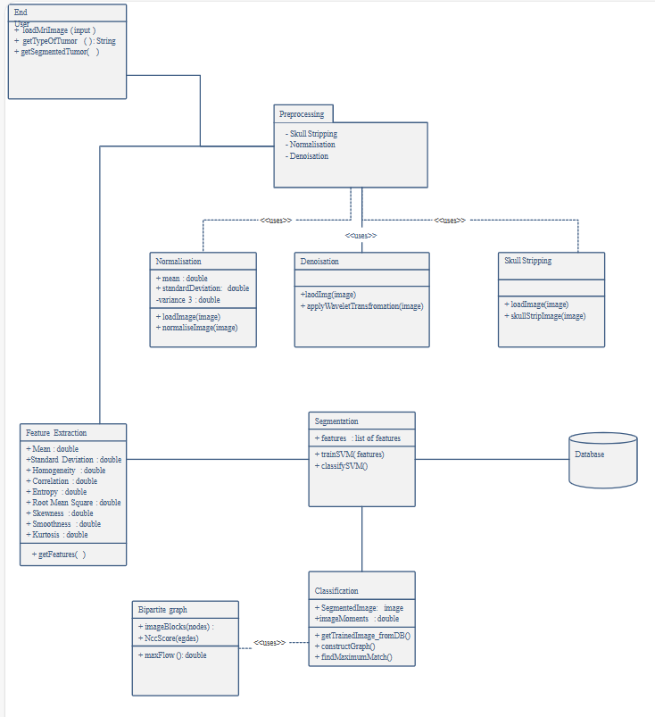

**Block Diagram:-** A block diagram is a schematic representation that illustrates the structure and connections between different components or blocks within a system. It provides a high-level overview of the system's architecture and relationships, simplifying complex systems into easily understandable visual diagrams.

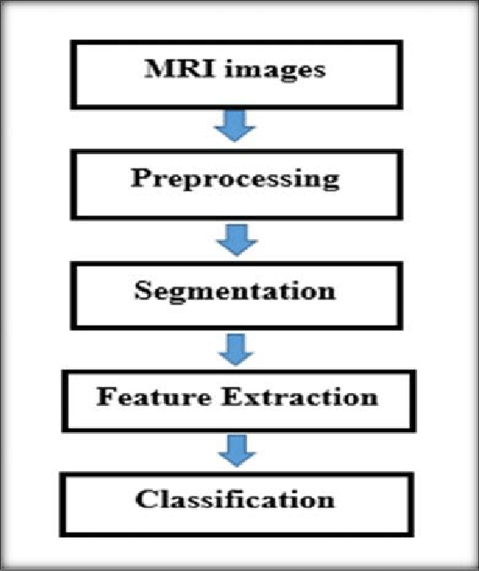

**ER diagram:-**An Entity-Relationship Diagram (ER Diagram) is a graphical representation that illustrates the relationships between entities (important things) in a system. It's a core concept in database design and helps visualize the data model.

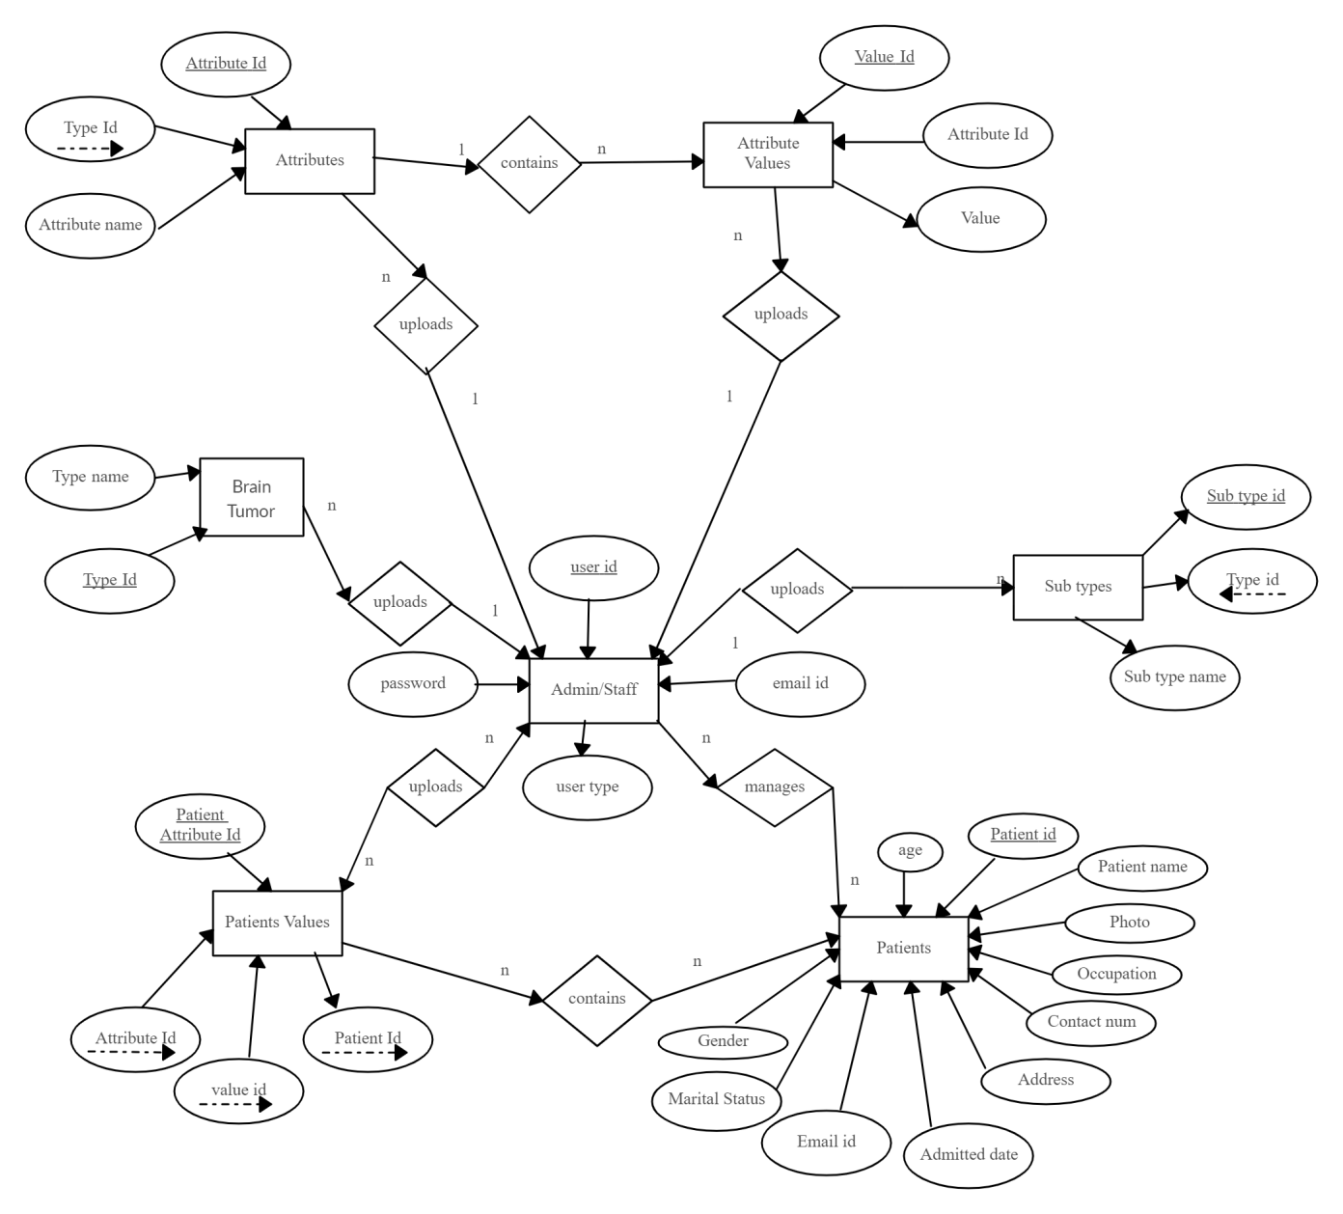

**5.2 Coding Standards:**

**Frontend Design:**

The frontend design maintains consistent naming conventions and utilizes meaningful names for variables, functions, and components. It organizes components into modular structures and ensures readability through clear comments and documentation. Additionally, the codebase maintains consistent whitespace, implements robust error handling, and incorporates accessibility features, adhering to coding standards and enhancing overall quality.

**Backend Design:**

The backend design follows coding standards by organizing code into logical modules and implementing separate files for different components. Data preprocessing methods ensure data quality and compatibility with machine learning algorithms. Machine learning algorithms, including convolutional neural networks, are utilized for training the brain tumor detection model. Hyperparameter tuning techniques, such as cross-validation and grid search, optimize model performance and robustness.

5.3 Testing Standards

**Unit Testing:-** Implement unit tests for individual components such as data preprocessing methods, model training functions, and prediction generation algorithms to ensure they function as expected.

**Integration Testing**:- Conduct integration tests to verify the interaction between different modules of the brain tumor detection system, ensuring seamless communication and compatibility.

**End-to-End Testing:-** Perform end-to-end testing by simulating user interactions with the Flask web application, including uploading MRI images and receiving prediction results, to validate the entire workflow.

**Performance Testing:-** Evaluate the performance of the system by measuring response times for image processing and prediction generation, ensuring efficiency under varying loads.

Chapter 6

Conclusion and Future Scope

**6.1 Conclusion**

Certainly! Here's a conclusion on the topic of a Brain Tumor detection system :

The brain tumor detection system presented in the provided code marks a significant step forward in leveraging machine learning for medical diagnostics. By employing convolutional neural networks (CNNs) and Flask web application framework, the system enables accurate classification of brain tumor presence from MRI images. Through meticulous data preprocessing, model training, and integration with a user-friendly web interface, the system offers a seamless experience for both medical professionals and patients.

The implementation adheres to coding standards and incorporates robust testing methodologies, ensuring reliability, efficiency, and security. Through unit testing, integration testing, and end-to-end testing, the system's functionality is thoroughly validated, guaranteeing accurate predictions and smooth operation. Additionally, performance testing assesses the system's responsiveness and scalability under varying loads, providing assurance of its effectiveness in real-world scenarios.

The system's success lies in its ability to democratize access to advanced medical diagnostics, empowering healthcare professionals with a tool capable of aiding in timely and accurate tumor detection. Furthermore, its intuitive interface fosters user engagement and enables seamless interaction, enhancing the overall user experience.

Moving forward, continuous refinement and optimization of the system can further enhance its capabilities and extend its impact in the field of medical imaging. This includes exploring advanced machine learning techniques, refining the user interface for enhanced usability, and incorporating feedback from medical practitioners to tailor the system to their needs.

In conclusion, the brain tumor detection system presented in the provided code represents a significant milestone in the intersection of machine learning and healthcare, promising improved patient outcomes and contributing to advancements in medical diagnostics.

**6.2 Future Scope :**

The future prospects for the brain tumor detection system depicted in the provided code are promising, suggesting numerous avenues for further enhancement and refinement.

Advances in artificial intelligence, particularly in deep learning methodologies, offer potential for improving the system's accuracy and reliability. By integrating more advanced neural network architectures and exploring techniques such as transfer learning, the system could achieve greater sensitivity in detecting subtle tumor characteristics within MRI images.

Additionally, optimization for real-time processing could enable swift tumor assessments during medical imaging procedures, facilitating prompt clinical decision-making and patient care. Expanding the system's capabilities to support multi-modal imaging data, including integration with complementary imaging modalities like CT or PET scans, could provide a more comprehensive understanding of brain tumors and improve diagnostic accuracy.

Collaborating with medical professionals for clinical validation and regulatory compliance would be essential for the system's integration into real-world healthcare settings, ensuring its clinical efficacy and adherence to medical standards. Furthermore, adaptation for telemedicine applications could extend the system's reach to remote or underserved areas, enabling access to expert diagnostics and facilitating remote consultations for improved patient outcomes.

Continuous maintenance, updates, and collaboration with researchers and clinicians will be imperative for the system's long-term success, allowing it to remain aligned with evolving healthcare needs and contribute to ongoing advancements in brain tumor diagnosis and treatment.

***References***

[1 ]S. M. Metev and V. P. Veiko, Laser Assisted Microtechnology, 2nd ed., R. M. Osgood, Jr., Ed. Berlin, Germany: Springer-Verlag, 1998.

1. Breckling, Ed., The Analysis of Directional Time Series: Applications to Wind Speed and Direction, ser. Lecture Notes in Statistics. Berlin, Germany: Springer, 1989, vol. 61.
2. S. Zhang, C. Zhu, J. K. O. Sin, and P. K. T. Mok, “A novel ultrathin elevated channel low-temperature poly-Si TFT,” IEEE Electron Device Lett., vol. 20, pp. 569–571, Nov. 1999.
3. M. Wegmuller, J. P. von der Weid, P. Oberson, and N. Gisin, “High resolution fiber distributed measurements with coherent OFDR,” in Proc. ECOC’00, 2000, paper 11.3.4, p. 109.
4. R. E. Sorace, V. S. Reinhardt, and S. A. Vaughn, “High-speed digital-to-RF converter,” U.S. Patent 5 668 842, Sept. 16, 1997.
5. (2002) The IEEE website. [Online]. Available: <http://www.ieee.org/>

[7] M. Shell. (2002) IEEEtran homepage on CTAN. [Online]. Available: http://www.ctan.org/tex-archive/macros/latex/contrib/supported/IEEEtran/